Policy Name | Pet Policy
Policy No. | 034

Introduction
GHA recognises that pets can have a very positive effect on people’s lives and can provide companionship and enjoyment for a great many people. We wish to support residents to be responsible pet owners and therefore do not impose unnecessary restrictions on pet ownership. Equally however we know that pets are expensive to look after and if not cared for correctly can cause damage to properties and be a nuisance and danger to other residents.
GHA’s policy aims to strike a balance so that responsible residents can enjoy the benefits of pet ownership but this is not an automatic right and permission will be withdrawn should owners not behave responsibly.
This policy covers the following issues
- What pets can be kept and in what circumstances
- The action GHA will take when pets are kept inappropriately or cause a nuisance to neighbours.

- Applicants applying for Social Housing

- Applicants for housing are asked to indicate on their application form if they intend to keep a pet. This will not prejudice their application unless they plan to keep a pet for which permission will not be granted. If this is the case the matter must be resolved before an offer of accommodation is made.

- Pet ownership not needing permission from GHA

- GHA permits tenants to keep a small number of pets without having to seek official permission from us. For example Rabbits, Guinea pigs, Mice, Dwarf hamsters or small caged birds e.g. Finches, Budgies or Canaries. This is only permission for a maximum of 1 or 2 small pets and permission is not granted for multiple small pets.
- Appendix 1 shows a full list of which animals are allowed without permission and in what numbers. It also clearly identifies animals which will not be permitted under any circumstances. This list has been drawn up in partnership with the States Veterinary Officer. Tenants are only permitted to have one type of pet from any one category. Should you want more than two small pets in total from any category you must seek permission from GHA.

- Obtaining permission for other pets such as a cat or dog

  - Anyone wishing to get a cat or a dog or a pet not on Appendix 1 would need to complete an application form requesting permission from GHA.
- If necessary GHA will seek advice from animal welfare agencies and The States Veterinary Officer but the decision as to whether permission will be granted will be with GHA as the landlord of the property.

- Permission will be granted if the:

- animal is suitable for the size of the property. To clarify; permission will not be granted for a dog unless there is an outside area, garden or balcony. House cats are permitted in flats, as long as they are kept within the property, and not allowed to roam in the communal areas.
- States Veterinary Officer agrees in writing to the GHA that the property is suitable for the animal
- space needed to keep the pet does not detract from the primary use of the property.
- breed of dog is on the GHA list of acceptable dogs Appendix 2.
- animal is kept on a leash in communal areas.
- animal is not a farm animal for example chickens or a pig.
- owner has the correct licence and/or permission from the States Veterinary Officer if required.
- potential owner has not been found guilty or been suspected of causing cruelty and neglect to an animal in the past.
- tenant is able to care for the pet (if for example through poor mobility or health the tenant is unable to care for the pet the tenant will need to make arrangements for the pet to be cared for).
- tenant does not owe GHA any money, has not fallen into rent arrears in the last 3 months and has a good history of rent payment.
- animal will receive regular treatment to avoid the risk of infestation in the property from fleas and other insects.
- animal does not pose any risk or danger to other residents.
- animal does not cause nuisance by excessive noise (barking, whining, howling or squealing).
- animal is not allowed to roam unattended and is kept under control (excluding cats).
- animal does not foul in neighbouring gardens or in communal areas on the estate.
- owner immediately clears up after their animal and bags up and discards appropriately any animal excrement either in a designated bin or takes it home to dispose of.
- keeping of the animal does not cause unpleasant odours for neighbouring properties.
- animal has been micro chipped.
- animal is neutered or will be neutered by a qualified Vet as it reaches an appropriate age for neutering.
- animal is not be kept or bred for any commercial purposes.
- tenant does not already have 2 dogs or 2 cats or a cat and a dog.

- Should these conditions not be kept to:

- GHA will withdraw consent for any pet(s) should:

- Any of the above conditions be breached or
- Where the keeping of such pets results in a breach of the tenancy or licence agreement

- Should the tenant breach these conditions GHA will commence legal action to repossess the property.

Appendix 1
The tables below indicate various categories of animals that tenants/license holders may be looking to keep as a small pet. The pets high-lighted in green do not need permission as long as the tenant/license holder complies with the maximum number and that where required they are neutered.
Tenants/License holders are only permitted 1 option from any section without asking for permission.
Should tenants wish to keep multiple pets they would need to obtain permission from GHA.
The tables indicate the maximum number allowed and the maximum number of cages.
Rodents - Female rabbits and guinea pigs should be neutered for health reasons and to prevent breeding.
Rodent size | Extra Large | Large | Medium | Small | Extra small
Examples | Giant rabbit | Rabbits | Chipmunks | Rats | Dwarf hamsters
 |  | Dwarf rabbits | Chinchilla | Gerbil | Mice
 |  | Guinea pigs  (out doors only) | Degu | Hamster (1)
Maximum number in this category | 4 | 4 | 4 | 4  Only 1 hamster | 4
Maximum number of cages | 2 | 2 | 2 | 2 for rats/gerbils  1 cage for a hamster | 2
Where they must be kept | Outdoors  + neutered | Outdoor/indoor  + neutered | In/outdoor large cage required | Rats and gerbils need larger cages | Indoors

Birds – many exotic birds are protected under the CITES (Convention on International Trade in Endangered Species) regulation. Those highlighted in red are not permitted.
Bird Size | Extra Large | Large | Medium | Small | Extra -Small
Examples | Macaw | Amazons | Large Parakeets | Cockatiels | Finches
 | Large Cockatoos | Small cockatoos | Small Conures | Budgies | Canaries
 | Eclectus Parrot | African grey | Pionus Parrots | Lovebirds
 | Peafowl | Large conures | Lories and Lorikeets | Parrotlets
 |  | Mini- Macaws not permitted
Maximum number | Not permitted | 2 | 2 | 2 | 6
Maximum number of cages | None | 2 | 2 | 2 | 3
NOTE | Not permitted too loud | Mini Macaws not permitted

Reptiles and amphibians – tenants applying to keep reptiles and amphibians may require a licence to do so. Many exotic species of reptiles and amphibians are protected under the CITES regulation. Extra-large and large reptiles will not be permitted. Those highlighted in red are not permitted.
Reptile/amphibian size | Extra large | large | medium | Small | Extra-small
Examples | Iguana | Monitor lizard | Royal python | Chinese Water Dragon | Brown anole
 | Python | Tegus | Bearded Dragon | Corn snake
 | Boa | Snapping turtles | Rat Snake | Hognose snake
 |  |  | Kingsnake | Geckos | Geckos
 |  |  | Chameleons (2) | Chameleons
 |  |  | Tortoise | Frogs/Toads
 |  |  | Musk Turtles and Terrapins | Blue- tongue Skinks
Maximum number in this category (not including hatchlings and juveniles) | 0 |  | Only 1 snake in this category  2 of others. | 2 | 2
Maximum number of Vivarium ( indoor enclosure such as an aquarium or tank) | NOT PERMITTED | NOT PERMITTED | 2 | 2 | 2
 |  |  |  | Only locally bred frogs/toads due to disease in the UK

Invertebrate – many exotic species of Invertebrate are protected under the CITES regulation. No spiders and Scorpions will be permitted. Those highlighted in red are not permitted.
Invertebrate | Spiders / Scorpions | Mandtids cockroaches | Millipedes Stick Insects | Land crab | Land snails
Examples | Emperor Scorpions | Praying Mantis | Indian Stick Insects | Land hermit crabs | Giant African Land snails
 | Chilean Rose Tarantulas | Madagascar hissing cockroach | Jungle Nymphs
 |  |  | African Giant Millipedes
Maximum number in this category | NOT PERMITTED | 6 | 6 | 2 | 2
Maximum number of tanks | NOT PERMITTED | 2 | 2 | 2 | 1
Notes | Venomous not permitted |  |  | Keep with companions of their own size

Appendix 2

Breeds of Dog Considered Suitable for Guernsey Housing Association Accommodation

On the advice of the States Veterinary Officer; below is a list of dog breeds (including crosses between these breeds) that are deemed suitable for GHA properties.

ALL OTHER DOGS ARE NOT ALLOWED IN GHA PROPERTY
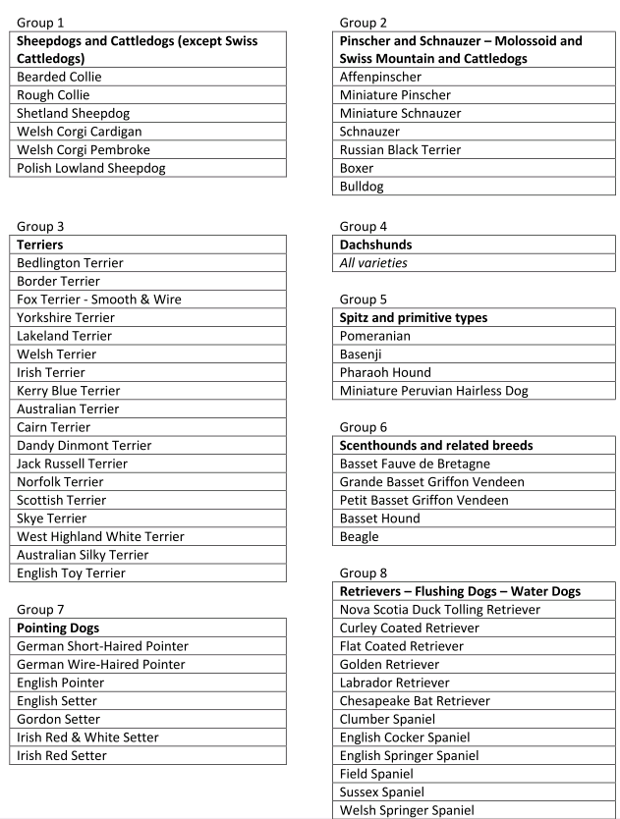
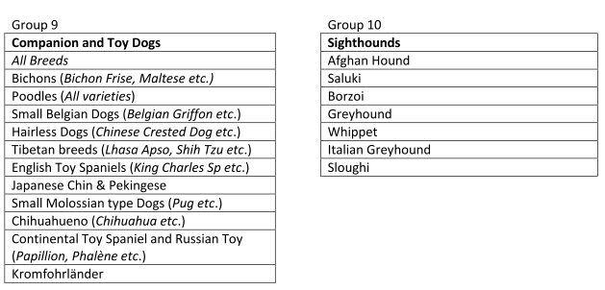

Date reviewed: December 2020 | Next review: December 2022

